Dynamic Tic Tac Toe Game Documentation

1. Introduction
The Dynamic Tic Tac Toe Game is a Python-based console application that allows two players to play Tic Tac Toe on a board of any size (3x3, 4x4, 5x5, etc.). This version is completely dynamic — players can choose their board size, and all winning conditions adjust automatically. It is made without any imports or external libraries, keeping it simple and easy to run in any Python environment.

2. Code Explanation

Class TicTacToe:
This class manages the entire game — including board creation, player moves, checking for wins/draws, and displaying the board.

def __init__(self, size):
This is the constructor. It initializes the Tic Tac Toe board with the given size. A list of lists (2D grid) is created where each cell is labeled with a unique number for easy player reference.
Example:
If the player chooses a 5x5 grid, the board will look like:
1 2 3 4 5
6 7 8 9 10
11 12 13 14 15
16 17 18 19 20
21 22 23 24 25

def display_board(self):
This function displays the current state of the board after each move. It ensures proper formatting regardless of board size and replaces numbers with X or O when players make their moves.

def make_move(self, player, position):
This function is used to update the board when a player chooses a valid position. The player's symbol (‘X’ for Player 1 or ‘O’ for Player 2) replaces the chosen cell number. If the position is invalid (already occupied), the player is asked to try again.

def check_win(self, mark):
This method checks for all possible win conditions:
- All cells in a row have the same mark.
- All cells in a column have the same mark.
- All cells in the main diagonal or anti-diagonal match.
This logic automatically works for any board size, making it dynamic.

def is_draw(self):
This method checks if the game is a draw — meaning no spaces are left, and no player has won. It ensures the program ends properly when no further moves are possible.

def main():
This is the main controller function of the game. It:
1. Asks players for the desired board size.
2. Alternates turns between Player 1 (X) and Player 2 (O).
3. Displays the board after each move.
4. Checks for win or draw conditions after every turn.
5. Ends the game when a player wins or the game is drawn.

Example Output

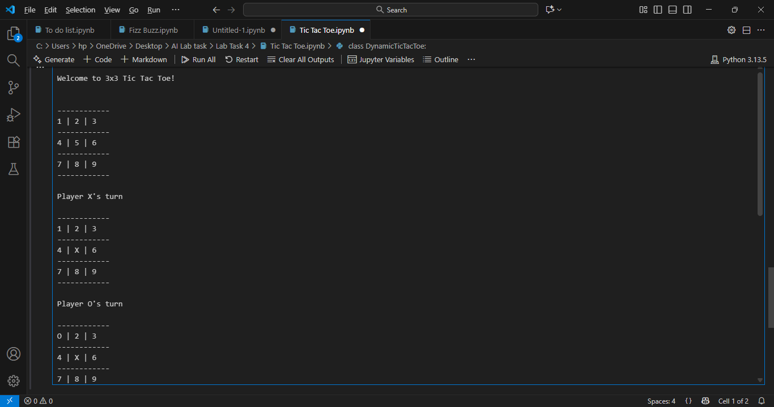
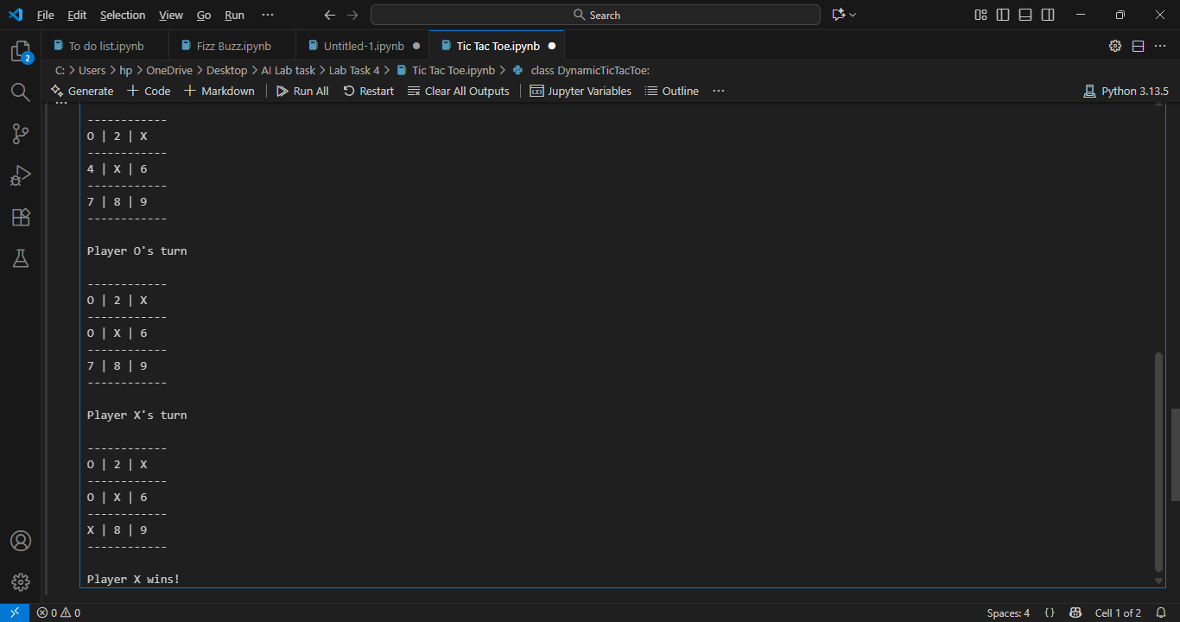

4. Key Python Concepts Used
Concept | Use in Project
Class | Encapsulates all game functionalities
List of Lists | Represents the dynamic Tic Tac Toe board
Loop | Keeps the game running until win/draw
Conditional Statements | Checks all win/draw conditions
Functions | Improve code organization and readability
User Input | Allows both players to play interactively

5. Conclusion
This project demonstrates how to build a dynamic and modular Python game using only core programming concepts. It effectively applies object-oriented programming, loops, lists, and conditional logic to make the Tic Tac Toe game flexible for any board size. The program is simple, readable, and provides a fun way to understand logic building and OOP concepts in Python.

